TASK RECORD

NAME: VIKASINI.K
DEPARTMENT: B. Tech CSE (Artificial Intelligence and Data Science)
COLLEGE: Vels institute of science, Technology and Advanced studies
INTERNSHIP ROLE: Data Analyst TASK: Documentation on IPv4 and IPv6 Introduction:
IP means Internet Protocol. It is used to give a unique address to devices connected to a network. This address helps the devices communicate with each other and send and receive data.
There are two main versions of IP:
- IPv4 – Internet Protocol Version 4
- IPv6 – Internet Protocol Version 6
TASK1: IPv4(Internet Protocol Version 4)
IPv4 is one of the commonly used world wide protocols for communication between devices in a network. It uses a 32-bit address. It is written as four numbers separated by dots.
For example:
192 . 168 . 1 . 10.
IPv4 has a limited number of addresses because it uses only 32 bits. Each octet has 8bits and 256 bytes each. There is a possibilities of creating duplicate. As the number of computers, mobile phones, IoT devices and other devices increased, the available IPv4 addresses became decreased.

CIDR CALCULATION:
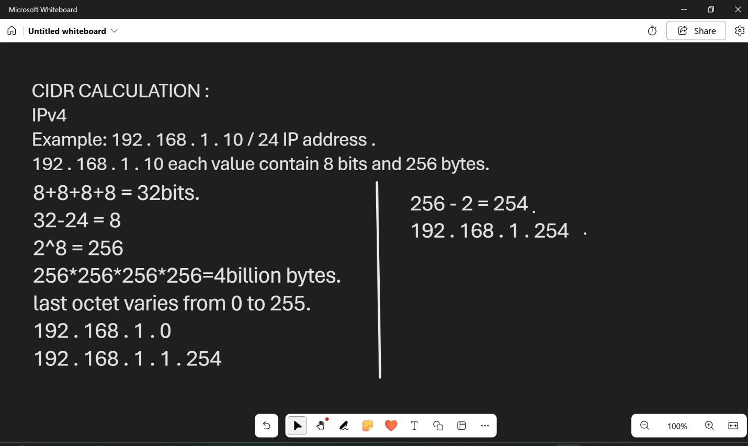

ADVANTAGES :
- It is widely used.
- It is easy to understand and configure.
- Most existing network devices support IPv4.
- It is commonly used in local networks.

TASK 2: IPv4(Internet Protocol Version 6)
IPv6 stands for Internet Protocol Version 6. It was developed mainly to solve the problem of limited IPv4 addresses. IPv6 uses a 128-bit address, so it can provide a very large number of addresses. Unlike IPv4, IPv6 addresses are written using hexadecimal numbers and separated by colons.
Example:
2001 : db8 : abcd : 0012 : 0000 : 0000 : 0000 : 0001.
An IPv6 address has 8 groups, and each group contains 16 bits. IPv6 also supports features such as automatic address configuration, which can make network configuration easier. There is no change to create duplicate. First 64 bits are Network. Last 64 bits varies are Host.

CIDR CALCULATION:
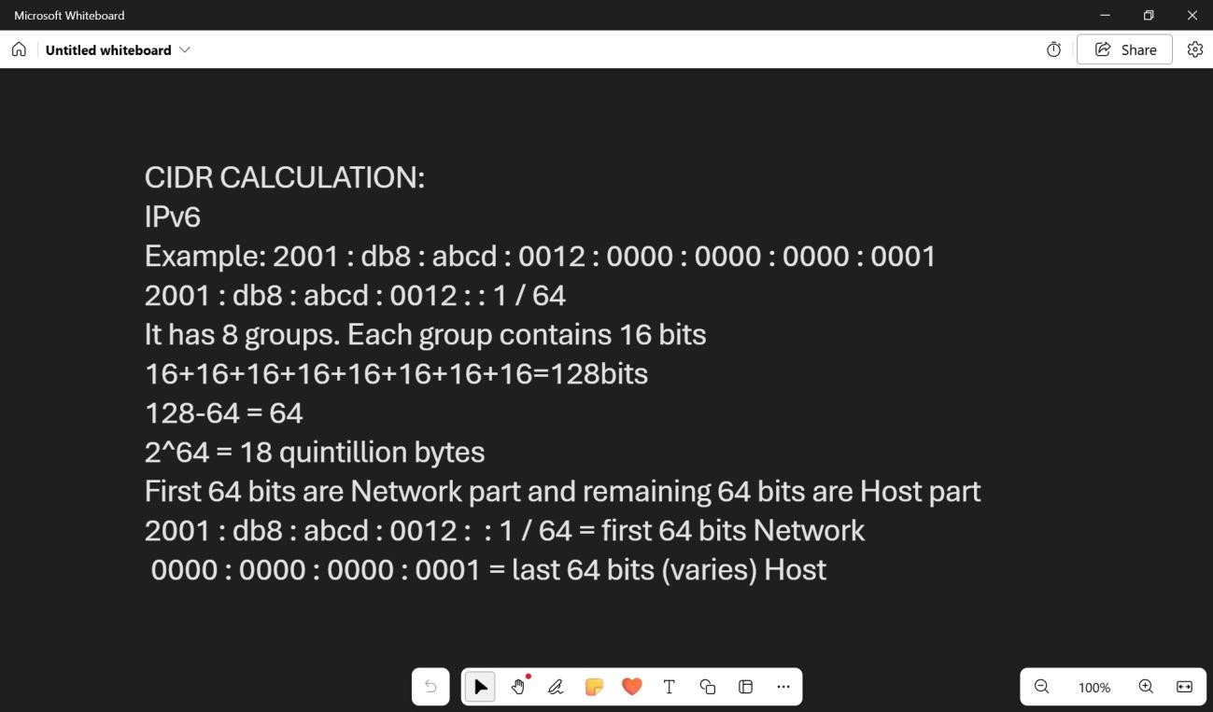

ADVANTAGES:
- It provides a very large number of IP addresses.
- It can support the growing number of internet-connected devices.
- It supports automatic address configuration.
- It was designed for modern and future networking needs.
SHORT FORM:
IPv4:
- Uses 32 bits
- Uses decimal number
- Uses dots (.)
- Example: 192.168.1.10
- Limited number of addresses
- Older version IPv6L:
- Uses 128 bits
- Uses hexadecimal numbers
- Uses colons (:)
- Example: 2001 : db8 : abcd : 0012 : 0000 : 0000 : 0000 : 0001
- Very large number of addresses
- Newer version

MY UNDERSTANDING:
IPv4 and IPv6 are used to identify devices in a network and help them communicate with each other. IPv4 uses 32 bits, so the number of available addresses is limited. IPv6 uses 128 bits, so it can provide a much larger number of addresses. IPv4 has a smaller address space, while IPv6 has a much larger address space for the increasing number of devices connected to networks. By practicing CIDR calculations such as /24, /26, and /27, I can understand how IP addresses are divided between the network part and the host part.
Conclusion:IPv4 and IPv6 are important parts of computer networking. IPv4 uses 32-bit addresses, while IPv6 uses 128-bit addresses. CIDR helps us calculate the network size and number of available hosts in IPv4 networks.

